## International Islamic University Islamabad

*Faculty of Engineering & Technology Department of Electrical and Computer Engineering*



Project Report

*for*

Digital Logic Design Lab

Submitted By: Muhammad Yaseen

Group Members: Muhammad Yaseen

Umer Hayat

Kumail Raza Kazmi

Farhan Alam

Registration No: 21 / 22 / 24 / 40

Submitted to:

PROF.HARIS ANEES

**Abstract**

The "Smart LED Light Manager" project introduces an intelligent lighting system designed for optimal energy efficiency. By utilizing a dynamic LED sequencing approach, facilitated by the versatile 555 timer IC, the system achieves programmable durations of high and low light intensity periods. The project's core objective is to address energy consumption concerns associated with traditional lighting systems, providing an adaptive solution for both day and night illumination.

Introduction

**Motivation**

Traditional lighting systems often lack adaptability, leading to unnecessary energy consumption, heat-related issues, and concerns about the reliability of wiring in both residential and industrial settings. The Smart LED Light Manager aims to mitigate these challenges by dynamically adjusting illumination based on environmental conditions. The project seeks to contribute to sustainable energy practices by introducing an autonomous LED light management system that not only saves energy but also reduces heat issues and enhances system reliability in variable wiring conditions.

**Objectives**

1. Develop a smart LED light management system with adjustable time intervals for LED activation.
2. Utilize the 555 timer IC to achieve programmable LED sequencing.
3. Enhance energy efficiency by dimming one LED during the night while maintaining higher brightness during the day.
4. Mitigate heat issues and enhance reliability in varying wiring conditions.

**System Architecture**

**Components**

The Smart LED Light Manager incorporates the following key components:

* 555 Timer IC x 2 Nos
* 100uf Capacitor x 2 Nos
* 100k Resistor
* 47k Resistor
* 330 Ohms Resistor x 2 Nos
* Breadboard
* Connecting Wires

**Operational Overview**

The 555 timer IC, configured in an astable multivibrator circuit, provides precise control over LED activation and deactivation times. By adjusting resistor and capacitor values, the system achieves a 22-second activation period for the high-brightness LED during the day and an 8-second activation period for the dim LED during the night.

**Functionalities**

1. Adaptive Illumination:
   * Daytime: High-brightness LED active for 22 seconds.
   * Nighttime: Dim LED active for 8 seconds.
2. Dynamic Sequencing:
   * Achieved through programmable resistor and capacitor values in the 555 timer circuit.
3. Energy Efficiency:
   * Reduced energy consumption by dimming one LED during nighttime operation.
4. Heat Mitigation and Reliability Enhancement:
   * Addressing heat issues associated with traditional lighting systems.
   * Enhancing reliability in variable wiring conditions.

**Design and Implementation**

**Circuit Design**

The astable configuration of the 555 timer IC, with resistor R1 and R2, and capacitor C, determines the timing characteristics of the system. Careful selection of resistor and capacitor values ensures the desired LED activation intervals.

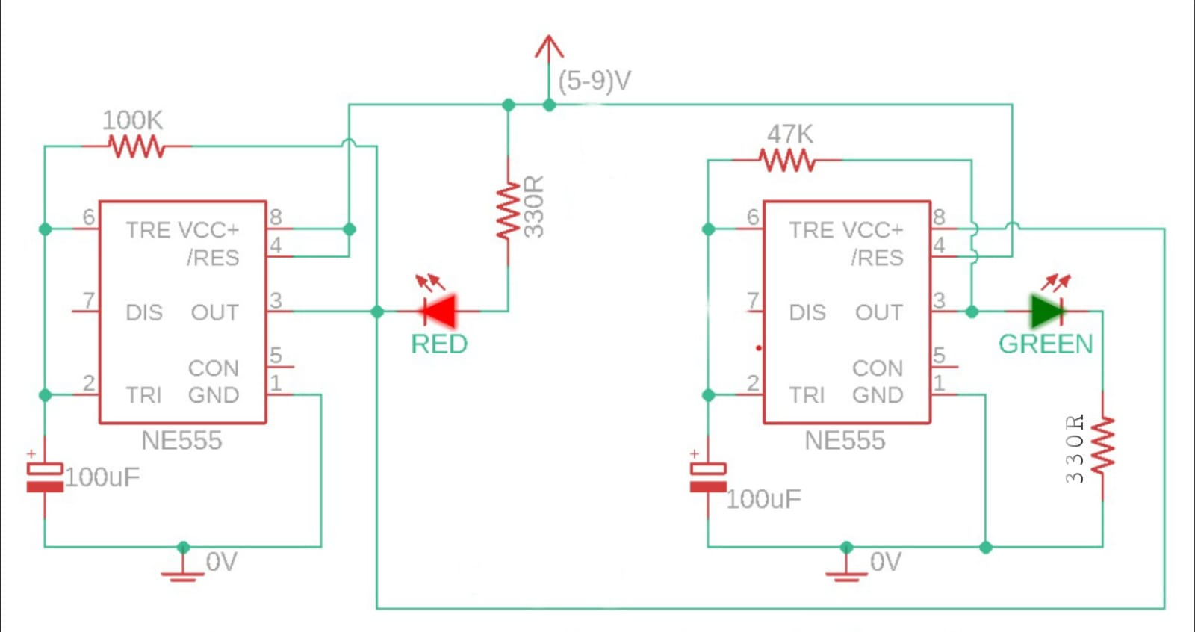

**LED Integration**

Two LEDs with different brightness levels are strategically integrated to cater to varying illumination needs. The LEDs are connected to the output of the 555 timer circuit.

**Testing and Results**

The Smart LED Light Manager underwent rigorous testing to validate its performance. The system consistently demonstrated the programmed LED activation sequences during both day and night conditions. Power consumption measurements affirmed the energy-efficient nature of the design.

**Conclusion**

The Smart LED Light Manager offers an efficient solution for optimizing energy consumption in lighting systems. By dynamically adjusting LED activation periods, the system demonstrates the potential for significant energy savings without compromising illumination quality. The additional benefits of heat mitigation and enhanced reliability make it a valuable solution for a wide range of applications.

**Future Work**

1. Integration of ambient light sensors for automatic adjustment based on environmental conditions.
2. Exploration of wireless communication for remote control and monitoring.
3. Investigation into additional energy-saving features, such as sleep modes during extended periods of inactivity.
4. Continuous refinement to adapt to evolving wiring conditions and enhance overall system robustness.

**Time Adjustment Formula**

The time period (*T*) in the astable multivibrator circuit is given by the formula:

**T=0.693×(R1*R2)×C**

Adjustments to *R*1, *R*2, or *C* can be made to vary the time period according to the desired illumination intervals. Experimentation and testing are crucial to fine-tune the system for optimal performance.